
Midterm

Name: Muhammad Osaf Ahmad Zaki
Reg#: BSE203022
Course: OOP-lab

Q1:
#include<iostream>
#include<string>
#include<fstream>
using namespace std;
class publication
{

protected:
string title;
float price;
public:
publication(){};

publication(string tit, float pri)
{
title = tit;
price = pri;
}
};
class book :public publication
{
protected:
int page_counter;
public:
book() {}
book(string t, float p) :publication(t, p) {} // parametrized constructor to assign the value of base class attributes
void setpage_count1();
int getpage_count2();
void put_datafile()
{
fstream file1;
file1.open("BookData.txt");
file1 << price << endl;
file1 << title << endl;
file1 << page_counter << endl;
file1.close();
}
void display_datafile()
{
ifstream file2;
file2.open("BookData.txt");
if (file2.is_open())
{
file2 >> price;
cin.ignore();
file2>>title;
file2 >> page_counter;
cin.ignore();
while (!file2.eof())
{
cout << "\nDisplay the values of Book\n";
cout << "The title : " << title;
cout << "\nThe price : " << price;
cout << "\nThe page count : " << page_counter;
file2 >> price;
cin.ignore();
getline(file2, title);
file2 >> page_counter;
cin.ignore();
}
}
file2.close();
}
};
void book::setpage_count1()
{
cout << "\n Enter the page count : ";
cin >> page_counter;
}
int book::getpage_count2()
{
return page_counter;
}
class tape :public publication
{
protected:
string tem1;
float tem2;
int tem3;
float playing_time_in_minutes;

public:
tape() {}
tape(string t, float p) :publication(t, p) {}
void setplaying_time_in_minutes();
float getplaying_time_in_minutes();
void put_data_into_file()
{
ofstream file1;
file1.open("BookData.txt", ios::app);
file1 << title << endl;
file1 << price << endl;
file1 << playing_time_in_minutes << endl;
file1.close();
}
void display_data_from_file()
{
ifstream file2;
file2.open("BookData.txt");
if (file2.is_open())
{
while (!file2.eof())
{
file2 >> tem2;
cin.ignore();
file2>>tem1;
cin.ignore();
file2 >> tem3;
cin.ignore();
file2 >> playing_time_in_minutes;
cin.ignore();
cout << "\nDisplay the values of Book\n";
cout << "The title : " << tem1;
cout << "\nThe price : " << tem2;
cout << "\nThe playing time in minutes : " << playing_time_in_minutes;
}
}
file2.close();
}
};

void tape::setplaying_time_in_minutes()
{
cout << "Playing time in minutes : ";
cin >> playing_time_in_minutes;
}
float tape::getplaying_time_in_minutes()
{
return playing_time_in_minutes;
}
string title()
{
string t;
cin.ignore();
cout << "\nTittle : ";
cin >> t;
return t;
}
float price()
{
float p;
cout << "\nEnter the price : ";
cin >> p;
return p;
}
int main()
{
cout << "\nEnter the data of class Book\n";
book obj1(title(), price());
obj1.setpage_count1();
obj1.put_datafile();
obj1.display_datafile();
tape obj2(title(), price());
cout << "\nEnter the data of class Tape\n";
obj2.setplaying_time_in_minutes();
obj2.put_data_into_file();
obj2.display_data_from_file();
}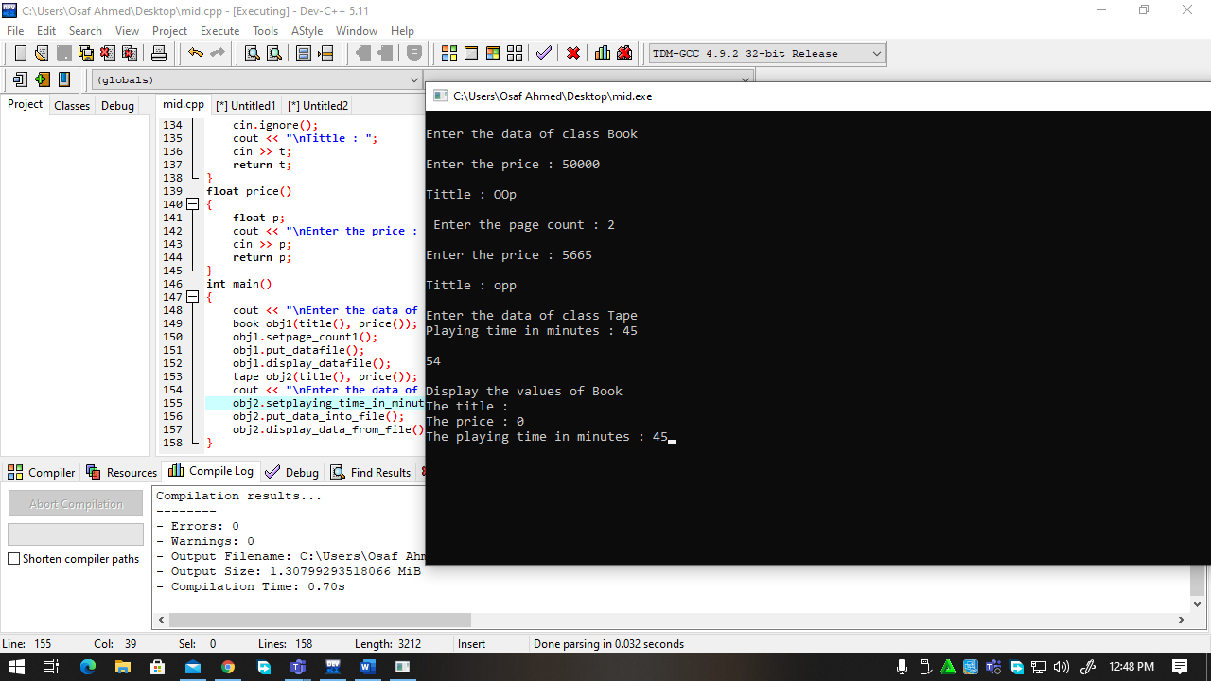
Q2):
#include<iostream>
#include<stdio.h>
#include<string>
using namespace std;
class matrix
{
protected:
int arr1[3][3];
public:
matrix()
{
arr1[3][3]=0;
}
matrix(int arr2[3][3])
{
arr1[3][3]=arr2[3][3];
}
void AddMatrix();
void MultiplyMatrix();
void isEqual();
};
void matrix::AddMatrix()
{
cout<<"Sum of matrix "<<endl;
int sum[0][0];
for(int o=0;o<3;o++)
{
for(int p=0;p<3;p++)
{
sum[o][p]=arr1[o][p]+arr1[o][p];
}
}
for(int o=0;o<3;o++)
{
for(int p=0;p<3;p++)
{
cout<<sum[o][p]<<endl;
}
}

}
void matrix::MultiplyMatrix()
{
cout<<"multiply Matrix "<<endl;
int multiply[0][0];
for(int q=0;q<3;q++)
{
for(int r=0;r<3;r++)
{
multiply[q][r]=arr1[q][r]*arr1[q][r];
}
}
for(int q=0;q<3;q++)
{
for(int r=0;r<3;r++)
{
cout<<multiply[q][r]<<endl;
}
}

}
void matrix::isEqual()
{
cout<<"MAtrix is equal "<<endl;
int equal[0][0];
for(int o=0;o<3;o++)
{
for(int p=0;p<3;p++)
{
equal[o][p]=(arr1[o][p]==arr1[o][p]);
if((arr1[o][p]==arr1[o][p]))
{
cout<<equal[o][p]<<endl;
}
}
}
}
int main()
{
matrix object;
object.AddMatrix();
object.MultiplyMatrix();
object.isEqual();
}
